RESUME

MADIREDDY SHASHANTH REDDY
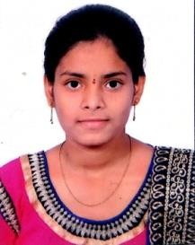
Email id: shashanthreddy01@gmail.com
Mobile: 7659999886

Objective:

- To enhance my professional skills, capabilities and knowledge in an organization which recognizes the value of hard work and trusts me with responsibilities and challenges.

Education:

Course | Institution | Year of passing | Percentage/cgpa
B. Tech(CSO)  ( pursing) | Ace engineering  college | 2025 | 7.2
Board of intermediate | Toppers junior college | 2021 | 73
Secondary School  (SSC) | St.Anthony Grammar high school | 2019 | 9.2
Skills:

- Personal skills : Adaptability, Hard Working.
- Programming skills : Java, C, Python.
- Operating Systems : Windows, linux.
- Database : Mysql.

Certifications:

- I have completed a Salesforce certification and got certified

Personal Details:

Name : Madireddy Shashanth Reddy

D.O.B : 19/12/2002

Father’name : M Malla Redy
Gender : Male Language known : English, Telugu
Address : Dammaiguda,Hyderabad opp old bus stopnear water tank
Hno- 2-79

Declaration:

- I hereby declare that the information mentioned above are correct to best of my knowledge and belief

M.Shashanth reddy

